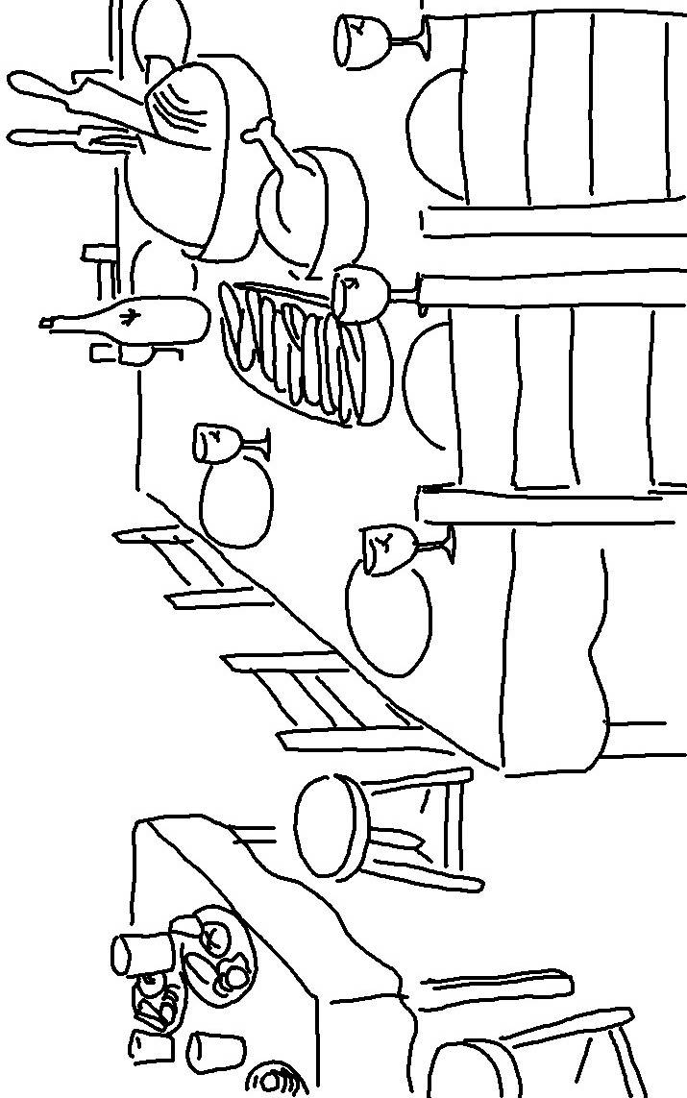
I will honor those who honor me.
1 Samuel 2:30

